QUILEUTE TRIBE
REQUEST FOR PROPOSAL
CONTRACT SERVICES

Project: Thunder Road Culvert Replacements & Road Work Plan
Project Location: Clallam County
La Push, WA
Quileute Indian Reservation
Section 22, Township 28 North, Range 15 West, W.M.

Proposal Due Date: March 2, 2017, 4:00 PM
Quileute Natural Resources P.O. Box 187 • 401 Main Street, La Push, WA 98331
Nicole Rasmussen, Project Lead, (360) 640-8042

Introduction:
The Quileute Natural Resources is requesting proposals from qualified firms for replacement of four culverts and reconstruction of 1.2 miles of Thunder Road on the Quileute Reservation.
Project Description:
Crossing Replacement #1:
The project consists of, but is not limited to, providing all materials, labor and equipment to remove an existing 3ft diameter x 30ft long corrugated metal pipe (CMP) culvert; and install a 8ft diameter x 40ft long aluminum culvert, construction of fill, riprap slope protection, stream bypass and project site dewatering, stream channel reconstruction, as well as associated approach work.

Crossing Replacement #2:
The project consists of, but is not limited to, providing all materials, labor and equipment to remove an existing 1ft diameter x 10ft long precast concrete pipe (PCP) culvert; and install a 8ft diameter x 40ft long aluminum culvert, construction of fill, riprap slope protection, stream bypass and project site dewatering, stream channel reconstruction, as well as associated approach work.

Crossing Replacement #3:
The project consists of, but is not limited to, providing all materials, labor and equipment to remove an existing 1.5ft diameter x 20ft long corrugated metal pipe (CMP) culvert; and install a 8ft diameter x 40ft long aluminum culvert, construction of fill, riprap slope protection, stream bypass and project site dewatering, stream channel reconstruction, as well as associated approach work.

Crossing Replacement #4:
The project consists of, but is not limited to, providing all materials, labor and equipment to remove an existing 5ft diameter x 37ft long corrugated metal pipe (CMP) culvert; and install a 24.5ft span x 22.5ft long x 8.2ft rise aluminum arch culvert on precast or CIP reinforced concrete footings, construction of fill, riprap slope protection, stream bypass and project site dewatering, stream channel reconstruction, as well as associated approach work.

Road Work:
The project consists of, but is not limited to, providing all materials, labor and equipment to perform work ranging from grading to reconstruction of an existing forest road alignment including clearing, grading, filling of the road prism, construction of pullouts, construction of an armored ford, turnaround, and ditch outs, and installation of cross drain culverts. Clearing, maintaining, and closing the spoils area shall be considered appurtenant to this portion of the work. Purchase of rock from a commercial source or excavation of material on-site, delivery of the material to the project site, placement and compaction of rock is part of this contract.

Roles and Responsibilities
The contractor has a contractual agreement with the landowner/operator for the project installation as set forth in the construction plan. The contractor shall not make changes to the construction plan without technical representative and landowner/operator approval. The contractor shall comply with all applicable permits and conduct the work in a safe manner. Work shall occur during times specified in this contract and by permits. Once commenced, the Contractor shall speedily pursue the completion of the work in a timely manner. The contractor is responsible for compliance with all state and local laws, ordinances, codes, and/or regulations applicable for the installation.

Questions, submittals, and requests for changes shall all be submitted to the Owner’s Representative (OR). The OR is the sole person who can authorize any changes during construction that incur financial obligations. There may be several persons representing the Owner on-site throughout the duration of the project for monitoring. Direction to the Contractor shall come from the OR unless agreed upon between the Contractor and OR. All permits, rights of ways, and/or easements applicable are the responsibility of the Owner and shall be provided to the Contractor upon approval.

Selected bidder must sign the following: the Quileute Personal Service Contract (PSC), meet the Performance Bond Requirements which is 100% of the contract price, fill out the Quileute New Vendor Application which includes application for certification as an Indian Preference Form (if applicable), Federal Debarment and Suspension Certification, proof of Insurance Requirements, a completed W-9, a Quileute Business License Application ($50), and a Vendor Conflict of Interest Disclosure Form (to certify there is no conflict of interest with any Tribal official, employee or employee’s immediate family.

Additionally, all bids must include a 5% Business and Occupation (B&O) tax for doing construction work (does not include cost of materials and supplies) with in the Quileute Reservation. Please embed the 5% tax within the bid, not an individual line item.

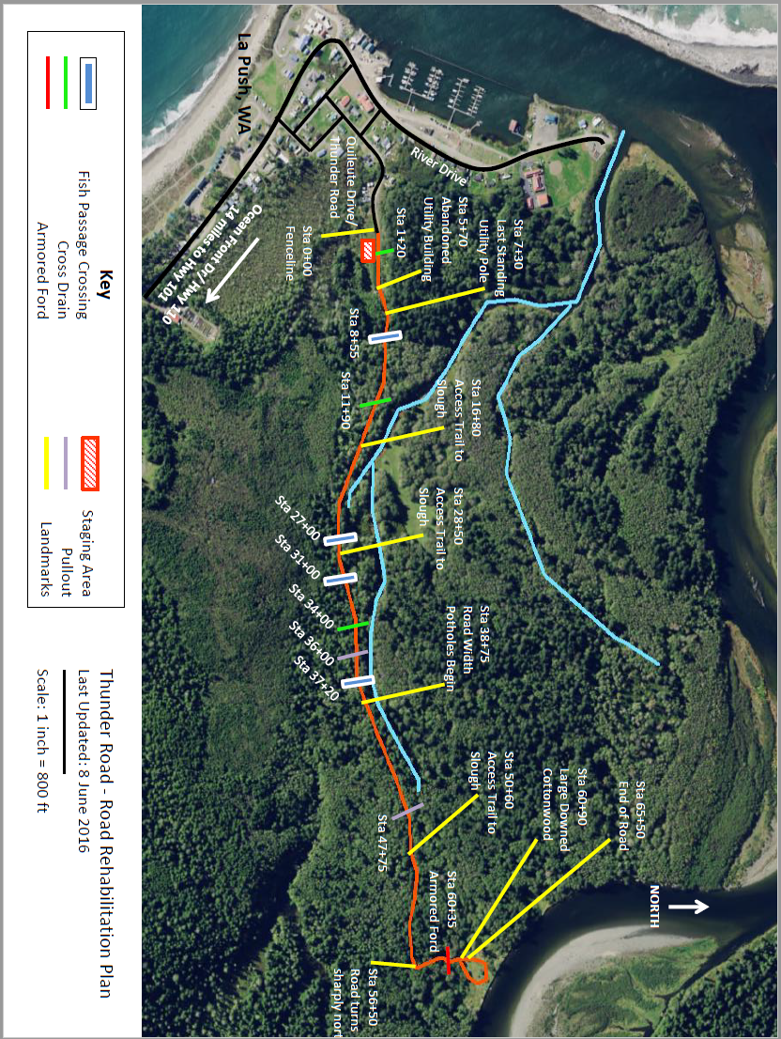
ROAD WORK

Road work, including staging of materials and not including removal or installation of live stream crossings, may occur between July 17 and September 30. Variances from that window must be approved in writing by the OR. Due to adverse weather and/or site conditions, this window may be delayed from opening or closed prematurely. Operation of construction equipment will not be permitted until 2 hours after sunrise and 2 hours before sunset until after September 23, or as dictated by permits. Variances from that window must be approved in writing by the Owner’s Representative. Operation of road construction equipment will be allowed on weekends or State recognized holiday (Labor Day) with authority in writing by the Owner’s Representative.

Aluminum Corrugated Metal Pipe Culverts
Aluminum stream crossing culverts shall be ordered from Contech Engineered Solution by March 15 and will be available for delivery after July 1 (no tax if delivered to the reservation). Aluminum coils shall conform to the applicable requirements of AASHTO M 197 or ASTM B 744. The Corrugated Aluminum Pipe shall be manufactured in accordance with the applicable requirements of AASHTO M-196 or ASTM B 745. The pipe sizes (8 foot diameter), lengths, gauges (10 gauge), and corrugations (3x1 or 5x1) shall be as shown on the plans. Bands shall be corrugated and per the manufacturer’s recommendations of length and gauge. Dimple bands are not allowed.

Aluminum Box Culvert
Aluminum box stream crossing culverts shall be ordered from Contech Engineered Solution by March 15 and will be available for delivery after July 1 (no tax if delivered to the reservation). Aluminum plate shall conform to the applicable requirements of AASHTO M 219 and ASTM B 864. The structure shall be or be similar in dimensions and load rating as a Contech Aluminum Box Culvert #78, D6 – 24’4” span, 8’2” rise, rated to HS 25 live load. The box shall come with prefabricated headwall and wingwalls with all associated hardware necessary for assembly. Panels shall be fabricated per the specifications in ASTM B746. Contract shall note the select backfill and compaction requirements specified by the manufacturer for this product.

Precast Concrete Footings
Precast concrete footings for the aluminum box culvert shall be ordered from Contech Engineered Solution by March 15 and will be available for delivery after July 1. If the Contractor wishes to propose a cast in-place equivalent, they shall propose that in the Bid Table. Precast concrete footings shall be designed and stamped by an engineer licensed in the state of Washington. They shall be designed to accommodate the above specified structure and live load and be appropriately sized for a bearing capacity of 2,000 psf. Installation shall conform to details and specifications provided by the manufacturer.

Expected Permitting Provisions
Permits from USFW & BIA are not in-hand yet. Provisions expected in the permits are as follows:
Dates: Work cannot commence till July 17 due to Quileute Days ending on July 16 and Northern spotted owl nesting restrictions ending on July 15. The NSO restrictions restrict work to between 2 hours after sunrise and ending 2 hours before sunset until September 23. All in water work must be done by September 30th due to hydrology of the area and the site conditions. All work is requested to be done by September 30th due to access to tribal fishing grounds.

In-Water Work Window: June 1st through September 30th

Dewatering: If water is present, all water must be contained to create a dry work area and water must be diverted downstream from construction area via pump.

Water Control: If rain or ground water arises during construction, all water must be contained from going downstream and sediment laden water must be pumped to forest floor before completion. Filter fence must be installed to minimize sediment delivery and contain any rainwater that may arise.

Restricted Work Hours due to ESA species: All construction will occur after July 15 (timed to avoid affecting Northern spotted owl) and be limited to the period beginning 2 hours after sunrise and ending 2 hours before sunset.

De-Fishing (if water is present) will be accomplished by the Quileute Natural Resources Staff. Contractor shall provide a minimum of two weeks’ notice prior to dewatering operations are to commence.

MEASUREMENT AND PAYMENT

PAYMENT OF LUMP SUM ITEMS
Bid Item 1 - Lump Sum - (Mobilization and Demobilization)
Mobilization and Demobilization shall cover the costs of moving all equipment to the job site; traffic control; cleaning up and removing any refuse; moving all equipment from the site; payment for signage, acquisition and payment for licenses, tribal or otherwise, fees, bonds and insurance.

Bid Item 2 - Lump Sum (Stream Crossing Replacement 1)
Stream Crossing Replacement 1 shall include the cost of all equipment, labor, and materials required to construct the project as shown on the plans and described in the specifications. Work shall include, but is not limited to, remove an existing 3ft diameter x 30ft long corrugated metal pipe (CMP) culvert; improving foundation conditions, installing a 8ft diameter x 40ft long aluminum culvert, construction of road fill, riprap slope protection, stream bypass and project site dewatering, stream channel reconstruction, and associated approach work.

Bid Item 3 - Lump Sum (Stream Crossing Replacement 2)
Stream Crossing Replacement 2 shall include the cost of all equipment, labor, and materials required to construct the project as shown on the plans and described in the specifications. Work shall include, but is not limited to, remove an existing 1ft diameter x 10ft long precast concrete pipe (PCP) culvert; improving foundation conditions, installing a 8ft diameter x 40ft long aluminum culvert, construction of road fill, riprap slope protection, stream bypass and project site dewatering, stream channel reconstruction, and associated approach work.

Bid Item 4 - Lump Sum (Stream Crossing Replacement 3)
Stream Crossing Replacement 3 shall include the cost of all equipment, labor, and materials required to construct the project as shown on the plans and described in the specifications. Work shall include, but is not limited to, remove an existing 1.5ft diameter x 20ft long corrugated metal pipe (CMP) culvert; improving foundation conditions, installing a 8ft diameter x 40ft long aluminum culvert, construction of road fill, riprap slope protection, stream bypass and project site dewatering, stream channel reconstruction, and associated approach work.

Bid Item 5 - Lump Sum (Stream Crossing Replacement 4)
Stream Crossing Replacement 4 shall include the cost of all equipment, labor, and materials required to construct the project as shown on the plans and described in the specifications. Work shall include, but is not limited to, removing an existing 5ft diameter x 37ft long corrugated metal pipe (CMP) culvert; and install a 24.5ft span x 22.5ft long x 8.2ft rise aluminum arch culvert on precast reinforced concrete footings, construction of fill, riprap slope protection, stream bypass and project site dewatering, stream channel reconstruction, as well as associated approach work. The cost of purchase and install or construction of cast in place footings should not be included here. Break this cost out in Alternate Bid items 10 & 11.

Bid Item 6 - Lump Sum (Access Road Work)
Access Road Work shall include, but is not limited to, providing all materials, labor, and equipment to perform work ranging from grading to reconstruction of an existing forest road alignment including clearing, grading, filling of the road prism, construction of pullouts, construction of an armored ford, turnaround, and ditch outs, and installation of cross drain culverts. Clearing, maintaining, and closing the spoils area shall be considered appurtenant to this portion of the work. Purchase of surfacing rock from a commercial source is expected. Excavation on-site or purchase and delivery of fill material, shall not be included in this bid. Costs of that material shall be addressed in Unit Bid Item 1 and 2. Compaction of that fill material and project site, placement and compaction of rock is part of this contract.

Bid Item 7 – Unit Bid (Production of Fill Material at Primary Owner Supplied Fill Source On-Site)
Production of Fill Material On-Site shall include, but is not limited to, providing all materials, labor, and equipment to clear, segregate non-conforming materials (if encountered), excavate, load, and protect the borrow area at the conclusion of work from erosion at the primary borrow source at the staging area. Washing, screening, or sorting is not anticipated to be required. Segregating non-conforming materials, stated above, would be required if the Contractor encounters a deposits of sand, organics, or buried wood in the borrow area. The quantity of fill to be dug and loaded is estimated to be 2,200 cubic yards in-place and 2,860 cubic yards in truck. The quantity available is estimated to be 4,200 cu yds. Contractor shall multiply their unit price times 2,860 cu yds and write that product as their unit bid entry for Bid Item 7. There is no charge to purchase this material from the Owner, only production costs.

Total Lump Sum Item Bids
Contractor shall sum Lump Sum Items 1-7 and enter that quantity in this row of the table. In the event of a mathematical error, the sum of the bid items will be used. Contractor selection will not be based solely on bid price, but also experience and references.

Alternate Bid Items
At the Owner’s discretion and upon Contractor agreement, some of the Alternate Bid Items may be used.

Bid Item 8 – Unit Bid (Production of Fill Material at Secondary Owner Supplied Fill Source On-Site)
Costs for Production of Fill Material at Secondary Site shall include, but is not limited to, providing all materials, labor, and equipment to load fill from the secondary borrow area at the water tower. Washing, screening, or sorting is not required. This source would be used if non-conforming materials are encountered at the primary source and it is deemed more cost effective to haul from the Secondary supply or if the selected contractor elects to haul from this location. The quantity available is estimated to be 3,000 cu yds. Contractor shall enter their unit price as their unit bid entry for Bid Item 8. There is no charge to purchase this material from the Owner, only production costs. Full truckloads would be the unit and means of measuring this material.

Bid Item 9 – Unit Bid (Purchase and delivery of crushed surfacing top course)
Costs for Purchase and delivery of crushed surfacing top course shall include, but is not limited to, providing all materials, labor, and equipment to load and transport crushed fill from a commercial source to the site. The quantity needed is estimated to be 2,910 cu yds. Contractor shall enter their unit price per cubic yard as their unit bid entry for Bid Item 8. Cost will be paid by multiplying the load ticket tonnage and a ratio of 1.4 tons per cubic yard. Should bids come in higher than funds available, some or all crushed surfacing work may be omitted from the contract work.

Bid Items 10 & 11 Cast In Place or Precast Strip Footings
Upon review of the responsive bids, the Owner will review available project finances and confer with the selected Contractor, to determine whether Lump Sum Items 10 or 11 will be employed for the arch install.

Bid Item 10 - Lump Sum (Crossing 4 - Cast In Place Reinforced Concrete Strip Footings)
Contractor shall construct and install Cast In Place Reinforced Concrete Strip Footings for Crossing 4. Contractor’s bid shall include the cost of all equipment, labor and materials required to procure an engineered design, form, reinforce, pour concrete, finish, and strip footings as shown on the plans and described in the specifications.

Bid Item 11 - Lump Sum (Crossing 4 - Precast Reinforced Concrete Strip Footings)
Contractor offload and install Precast Reinforced Concrete Strip Footings for Crossing 4 furnished by the manufacturer. Contractor’s bid shall include the cost of all equipment, labor and materials required to offload and place footings as shown on the plans and described in the specifications.

Unit Bid Item 12 (Over-Excavation)
Contractor shall include the cost of all equipment, labor, and materials required to over excavate, haul spoils to the spoils area, and maintain the spoils area by the yard should over-excavation be required. Additional dewatering measures, if any are required, shall be accounted for in this bid. The quantity to be paid by this item shall be measured by the following. The dimensions of the dump truck to be used to haul material shall be measured and the volume calculated. The number of loads hauled shall then be tallied and Contractor shall not proceed until Contractor and Owner agree on over-excavation being complete as specified and the number of loads hauled.

Unit Bid Item 13 (Subgrade Reinforcement)
Contractor shall include the cost of all equipment, labor, and materials required to purchase or produce, haul, place, and compact reinforcing fabric and quarry spalls.

TERMS AND CONDITIONS
1. The Quileute Tribe reserves the right to reject any and all proposals, and to waive minor irregularities in any proposal.

2. The Quileute Tribe reserves the right to request clarification of information submitted, and to request additional information from any proposer.

3. The Quileute Tribe reserves the right to award any contract to the next more qualified contractor, if the successful contractor does not execute a contract within fifteen (15) calendar days after the award of the proposal.

4. Any proposal may be withdrawn up until the date and time set above for opening of the proposals. Any proposal not so timely withdrawn shall constitute an irrecoverable offer, for a period of forty-five (45) days to sell to the Quileute Tribe, the services described in the attached specifications, or until one or more of the proposals have been approved by the Quileute Tribe administration, whichever occurs first.

5. The contract resulting from acceptance of a proposal by the Quileute Tribe shall be in a form supplied or approved by the Quileute Tribe, and shall reflect the specifications in this RFP. A copy of the contract is available for review. The Quileute Tribe reserves the right to reject any proposed agreement or contract that does not conform to the specification contained in this RFP, and which is not approved by the Quileute Tribe Attorney’s office.

6. The Quileute Tribe shall not be responsible for any costs incurred by the firm in preparing, submitting or presenting its response to the RFP.

7. All bid documents are public record and subject to disclosure.

8. Proposals failing to comply with the requirements of this Request for Proposal may be considered non-responsive.

Pre-bid Conference: Pre-bid Conference is set for 10:00 AM on Wednesday, February 22 at Quileute Natural Resources Office to go to Thunder Road Project site. Please bring all questions and inquires to the meeting.

Delivery: All bids are to be submitted by 4:00 PM on March 2. Bids can be mailed to QNR, PO Box 187, La Push, WA 98350 or sealed bids can be hand carried to QNR Office at 401 Main Street, La Push to front desk for an official stamp. Any questions, please contact Nicole Rasmussen at 360-640-8042.

Contractor Name:
Submission Date & Time:
Signature:

Bid Tabulation*

Bid Item No. | Bid Item | Bid Unit | Item Bid Amount
1 | Mob & Demob | Lump Sum
2 | Stream Crossing #1 | Lump Sum
3 | Stream Crossing #2 | Lump Sum
4 | Stream Crossing #3 | Lump Sum
5 | Stream Crossing #4 | Lump Sum
6 | Road Work | Lump Sum
7 | Produce 2,860 cu yds from Primary Borrow Source for road prism | Unit Bid
 |  | Total Lump Sum Bid
Alternate Bid Items
8 | Road Fill from Water tower Source | Unit Bid per cu yd
9 | Crushed Surfacing - Commercial Source
10 | Construct Cast In Place Footings | Lump Sum
10 | Precast Footings | Lump Sum
11 | Additional cross drain culverts | Unit Bid
12 | Over excavate unsuitable bearing soils | Unit Bid
13 | Replace unsuitable bearing soils with fabric & quarry spalls | Unit bid

*All bids must include a 5% Business and Occupation (B&O) tax for doing construction work with in the Quileute Reservation. No B&O tax will be taken from the cost of materials and supplies (e.g. rock, culverts, etc.). Please embed the 5% tax in your bid, not a separate line item.

Three Contractor References:
Name | Company/Title | Phone Number | Project Type

